99.99 Hz

Sine Wave

Triangle Wave

Square Wave

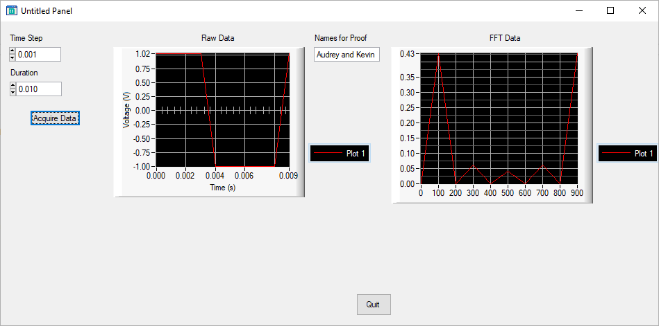

**Aliasing Testing**

**Duration: 0.1 s CONSTANT**

**Varying Freq and Sampling Rate:**

200 Hz, 0.001 s (1000 Hz):

200 Hz, 0.01 s (100 Hz)

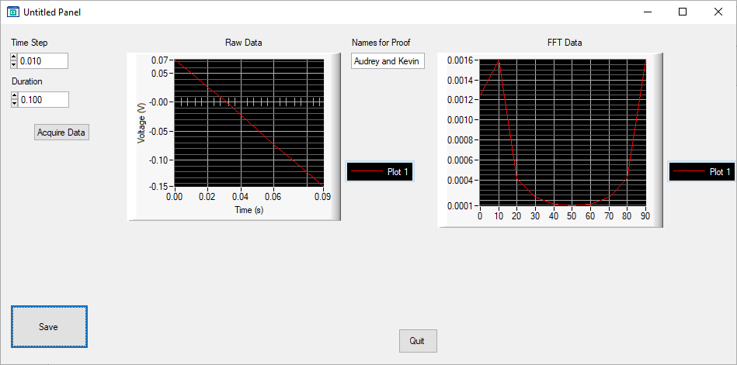

200 Hz .005 s (200 Hz)

50 Hz .001 (1000 Hz)

50 Hz .01 (100 Hz)

50 Hz .005 (200 Hz)

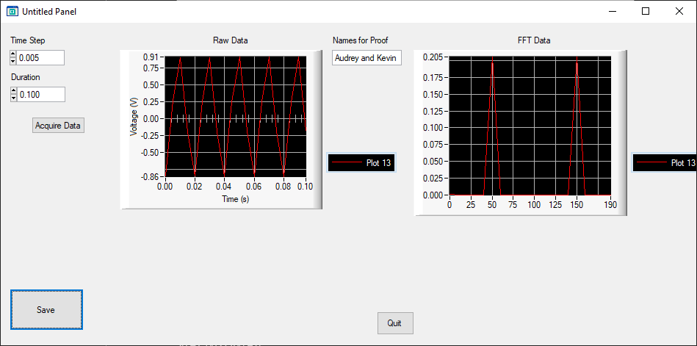

100 Hz .001 (1000 Hz)

100 Hz .01 (100 Hz)

100 Hz .005 (200 Hz)

